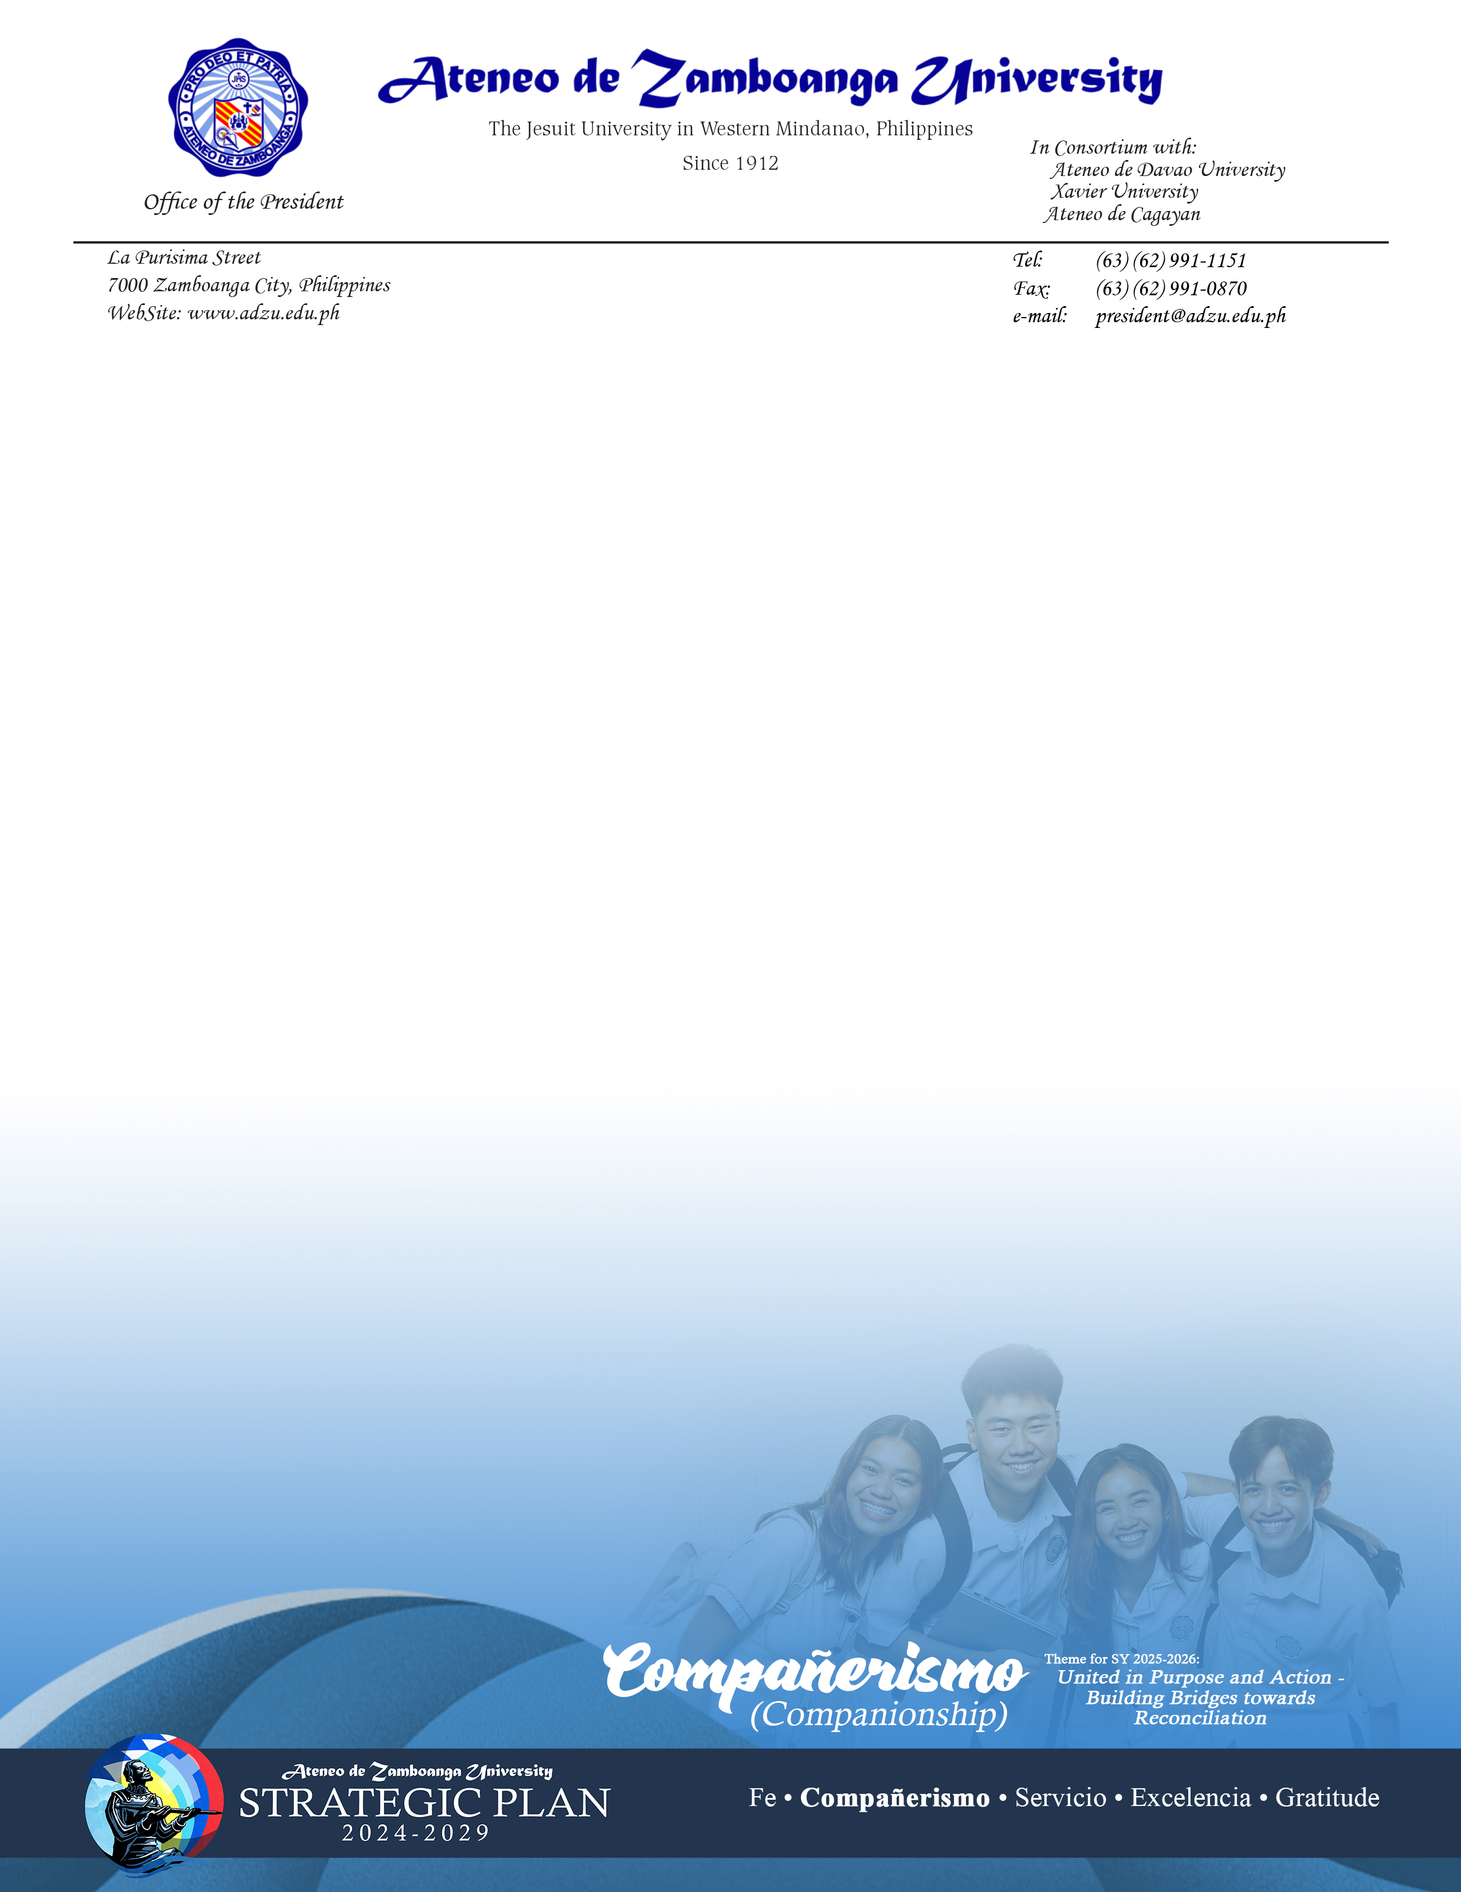

Office of the President

Tel: (63) (62) 991-1151

(63) (62) 991-0871 local 1002

Fax: (63) (62) 991-0870

e-mail: president@adzu.edu.ph